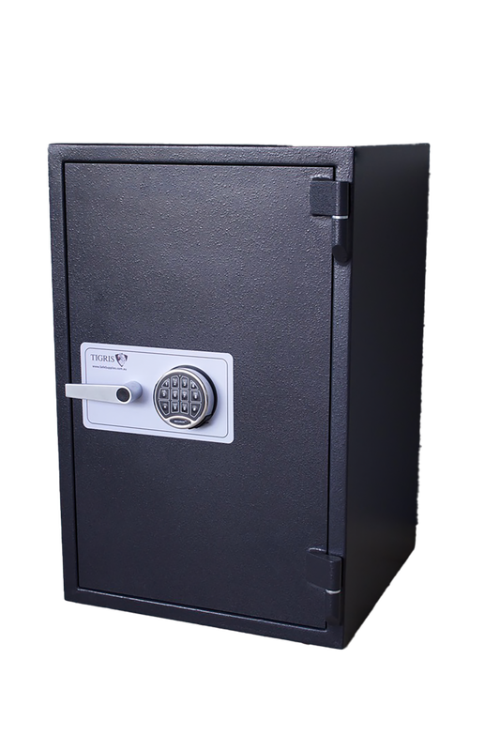
Location: Airport West, Victoria 3042.
External Measurements
H 650mm
W 435mm
D 360mm

Description: The CMI HG1+ (Home guard Plus) is a premium domestic security safe designed to provide reliable protection against burglary and fire. Featuring a robust 12mm solid steel door with a 10-point locking system, it delivers a high level of security for valuables & important documents.
The safe offers a 30-minute fire resistance rating to help protect its contents in the event of a fire. Weighing 104kg, it is supplied with four pre-drilled anchor holes for secure floor mounting, enhancing its resistance to unauthorised removal. Comes with or without stand.

Cash Rating: $50,000AUD
Model: CMI HG1 +
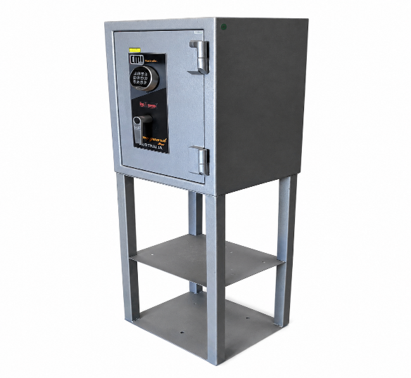
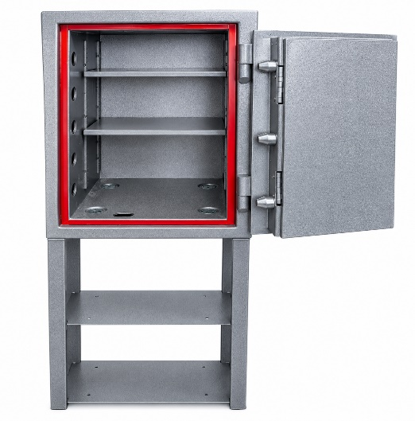
Fire Rating: 30 min with fire seals around door frames
USED SAFE
Internal Measurements
H 530mm
W 319mm
D 225mm
Price $1000 + GST

