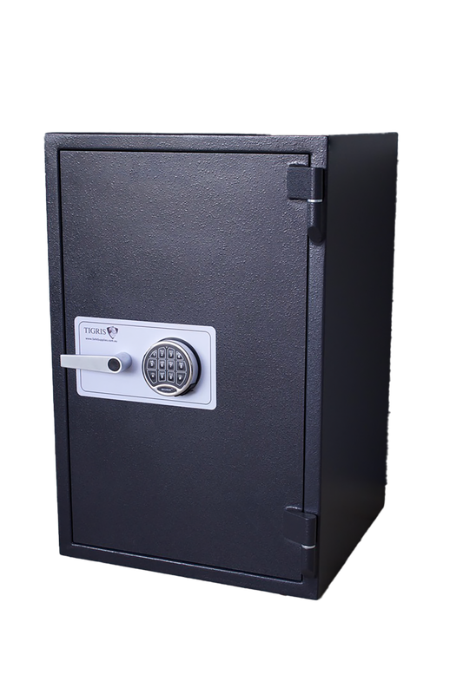
Price $800 + GST
Internal Measurements
H 725mm
W 410mm
D 400mm
External Measurements
H 915mm
W 610mm
D 595mm

Location Melbourne, Victoria

Description Own a piece of security history with an Antique Mosler Safe. Renowned for their exceptional craftsmanship, ornate cast-iron construction and timeless design, Mosler safes were trusted by banks, businesses and government institutions for over a century.
Fire Rating Unknown
Cash Rating Approx $20,000
Model Mosler Antique
Picture 2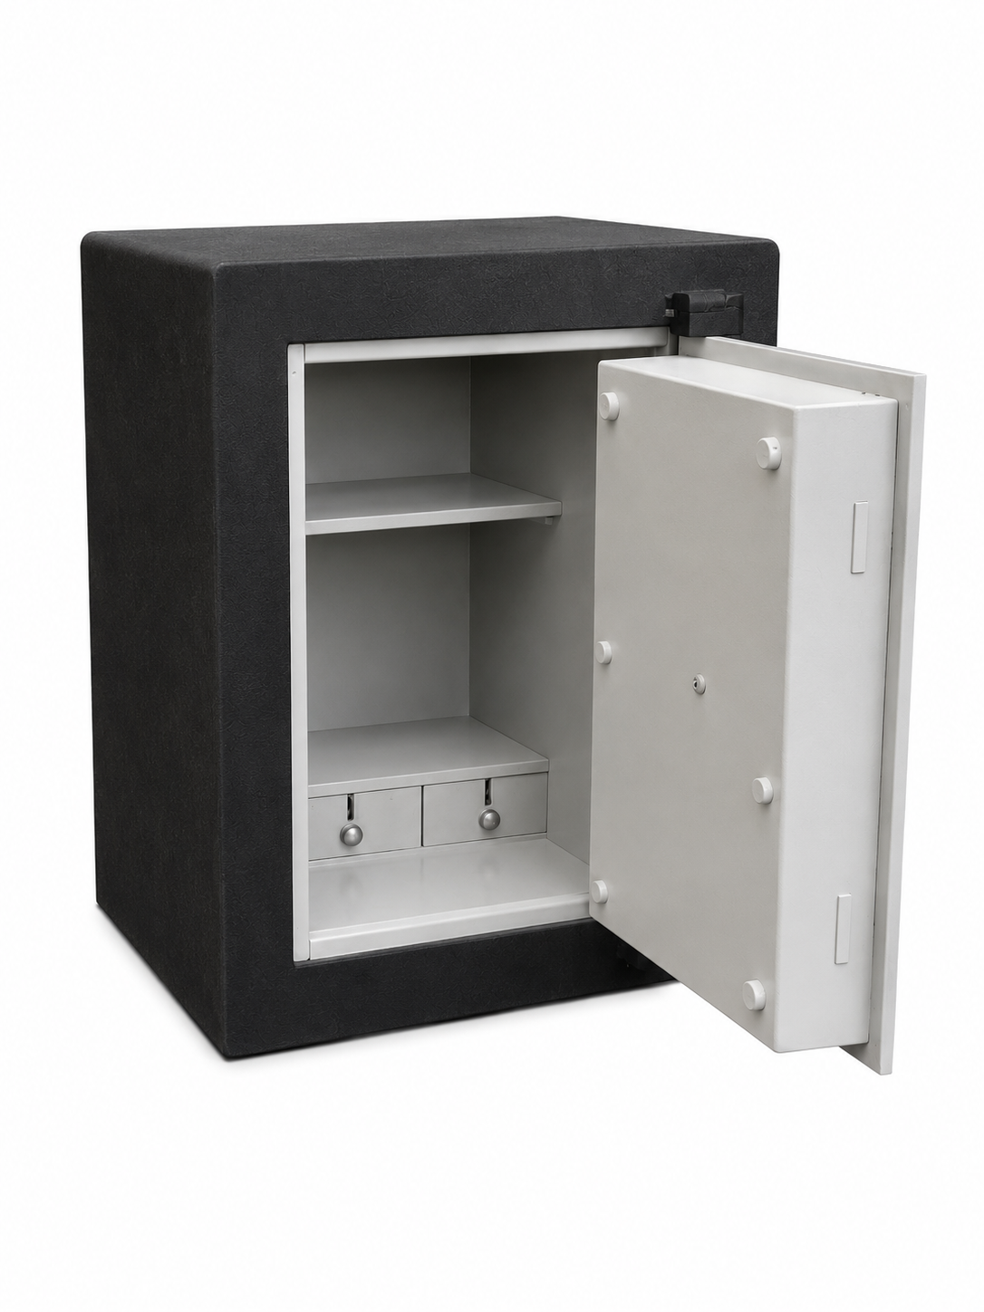

Picture 1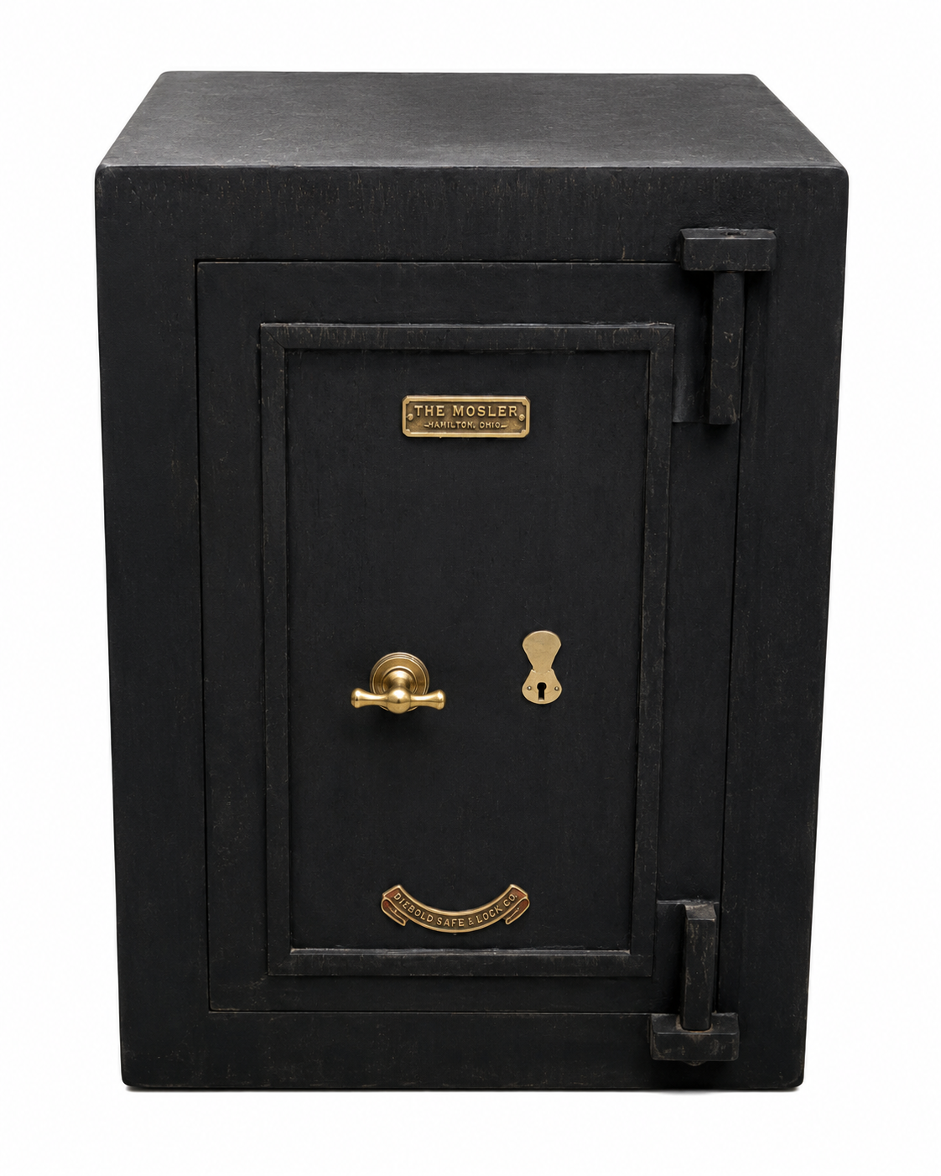
USED SAFE

