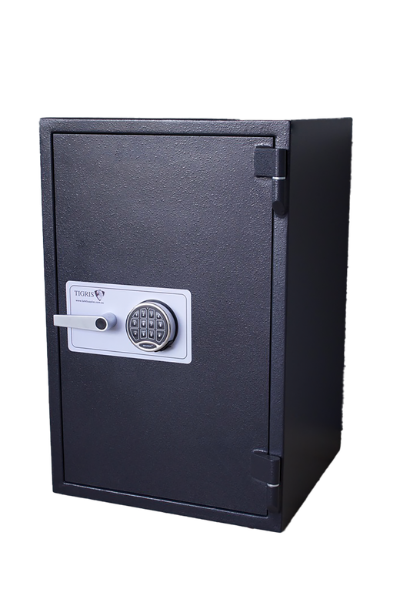
Price $800 + GST
Internal Measurements
H 500mm
W 340mm
D 400mm
External Measurements
H 665mm
W 505mm
D 515mm

Location Melbourne, Victoria
Description Add timeless character to your home or business with an Antique Bristol Safe. Built with traditional craftsmanship and durable steel construction, Bristol safes are prized for their classic appearance, solid security and historical appeal.

Professionally inspected by Safes & Vaults, each antique safe is unique, making it ideal as both a functional safe and a striking feature piece for homes, offices, wineries, retail stores or collectors.
Fire Rating Unknown
Cash Rating $20,000
Model Bristol Antique
Picture 2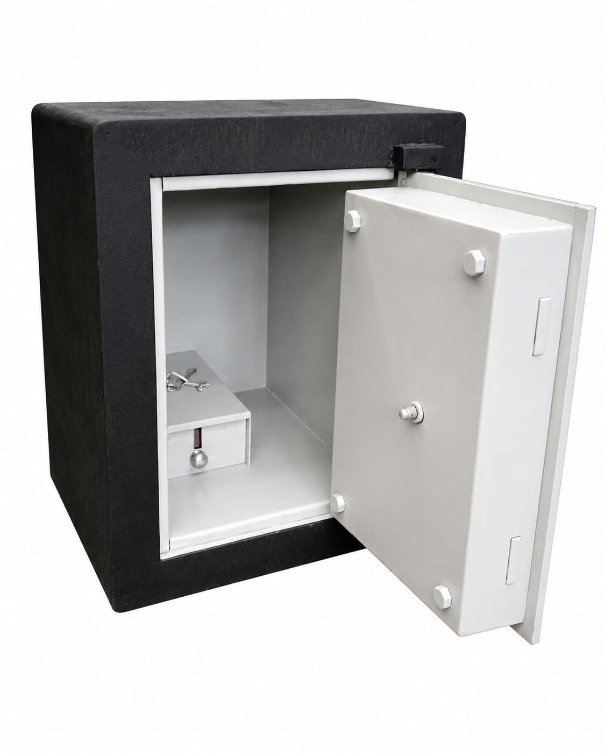

Picture 1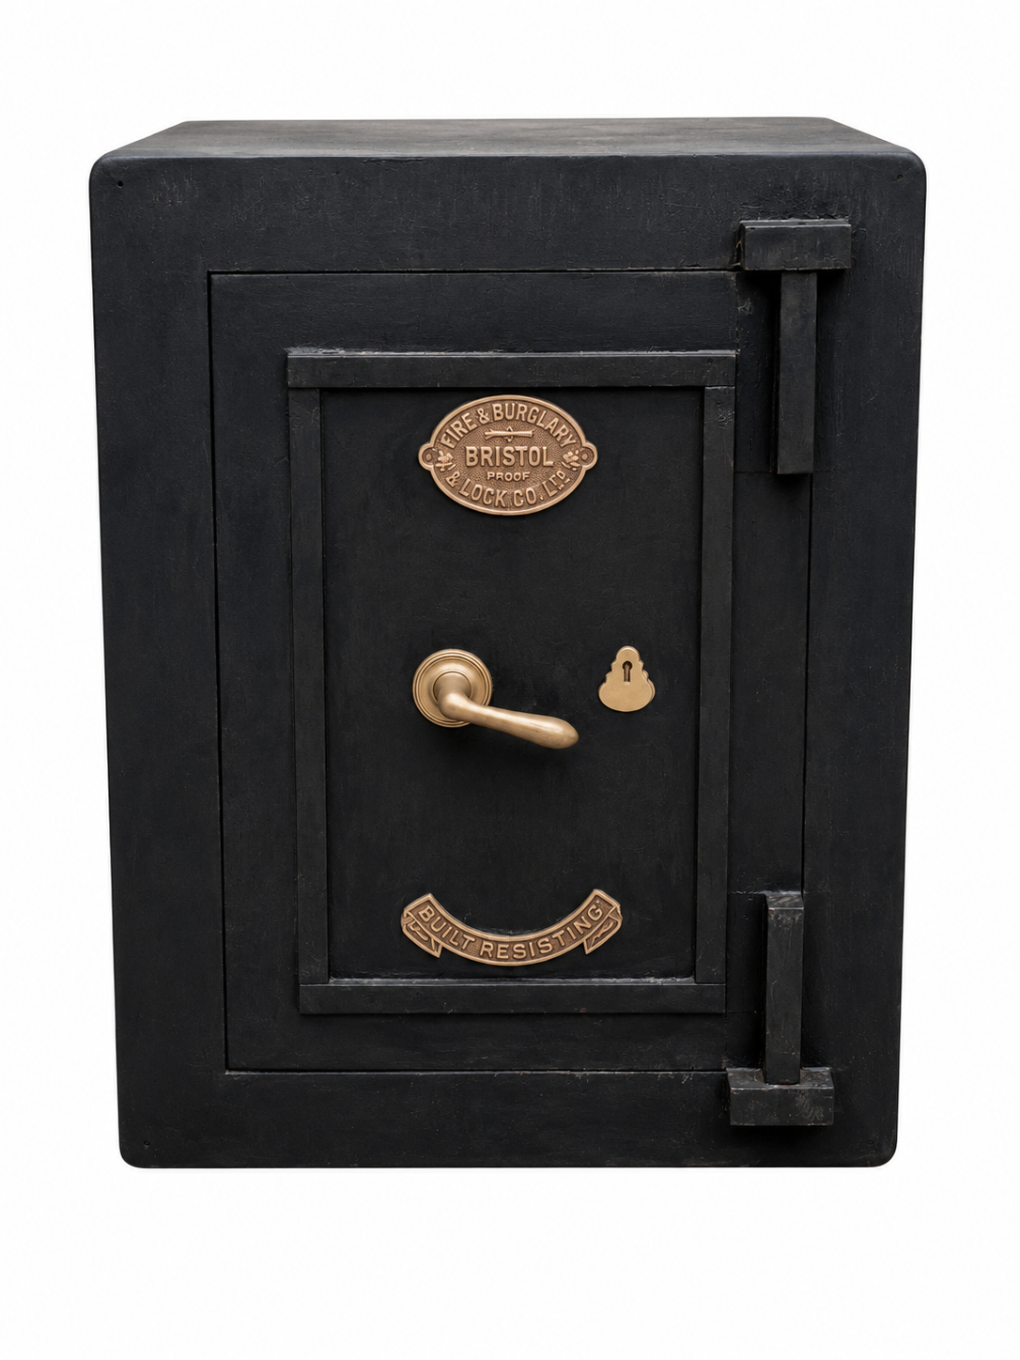
USED SAFE

