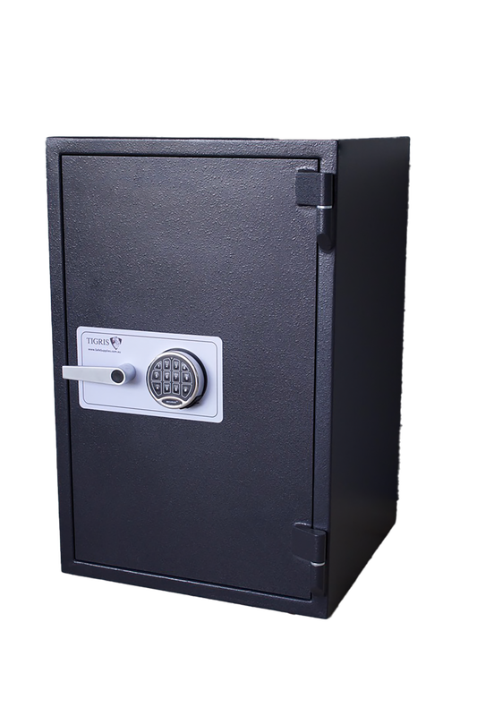
Description Cobra Safe is a premium commercial-grade safe that offers proven burglary protection combined with 30 minutes of certified fire resistance for important documents. Designed for businesses, retail stores and homeowners seeking reliable security, the Cobra range is renowned for its robust steel construction, heavy-duty locking mechanism and long service life. The Cobra range is certified to EN 1143-1 Grade I burglary resistance
Internal Measurements
H 620mm
W 500mm
D 500mm
External Measurements
H 750mm
W 630mm
D 575mm

Price $1600+GST
Location Melbourne, Victoria
Fire Rating 60mins
Cash Rating $50,000
Model Chubb Cobra
Picture 2 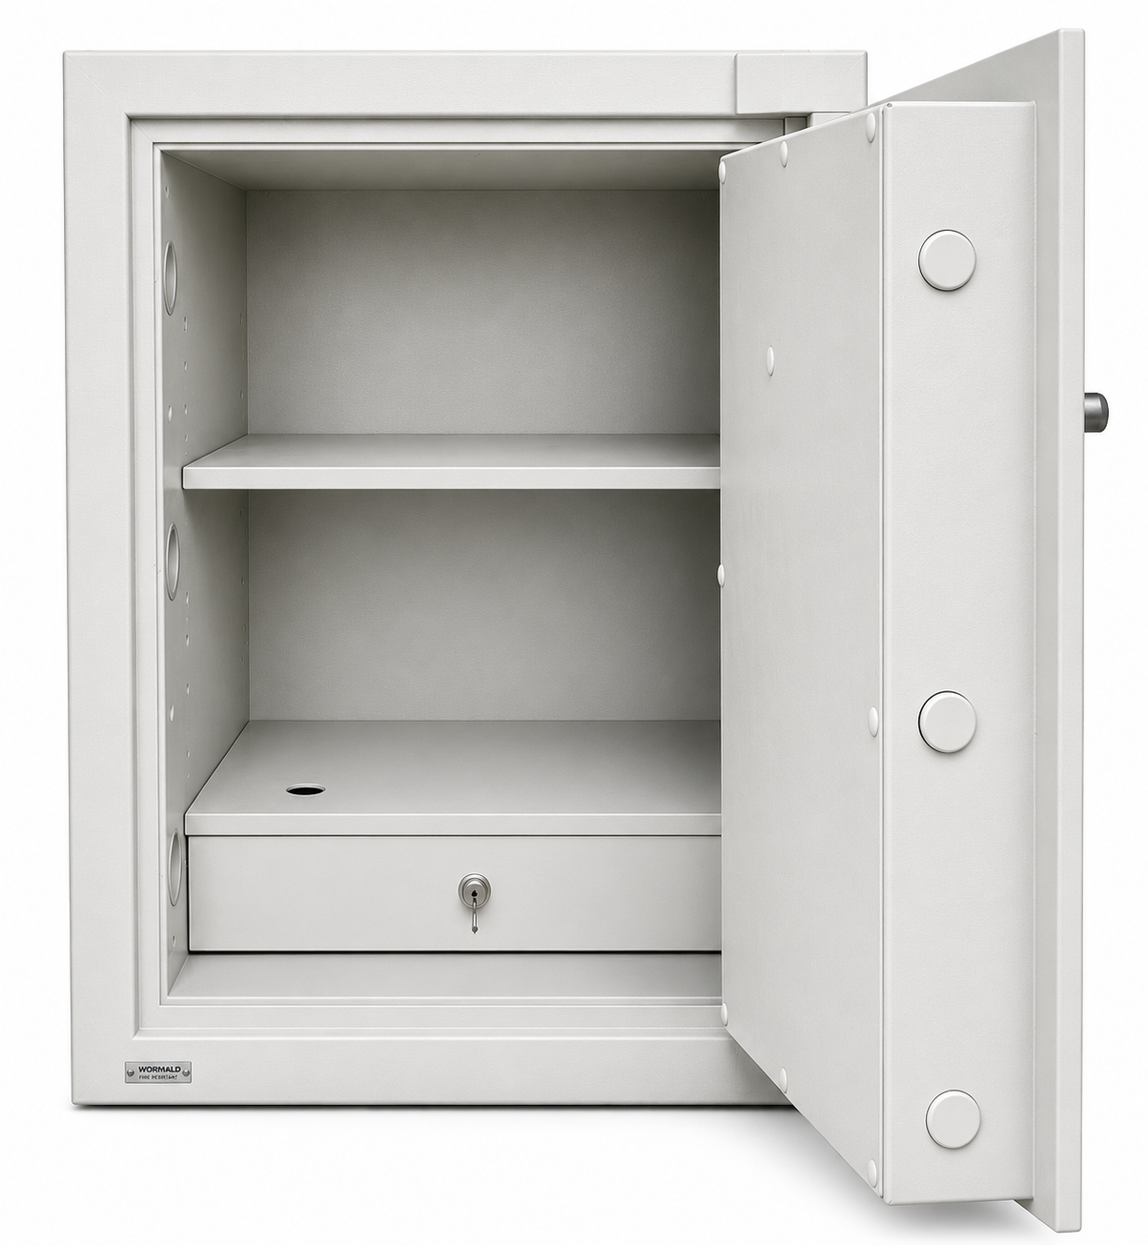
Picture 1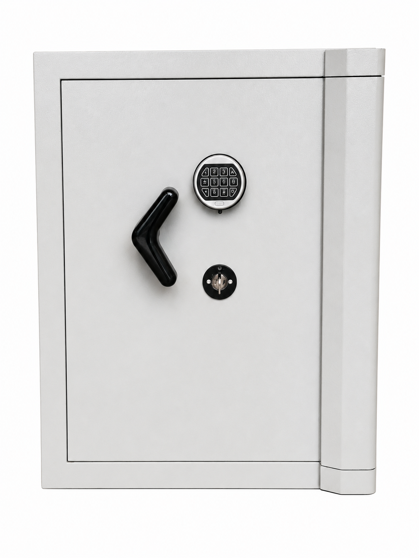
USED SAFE

