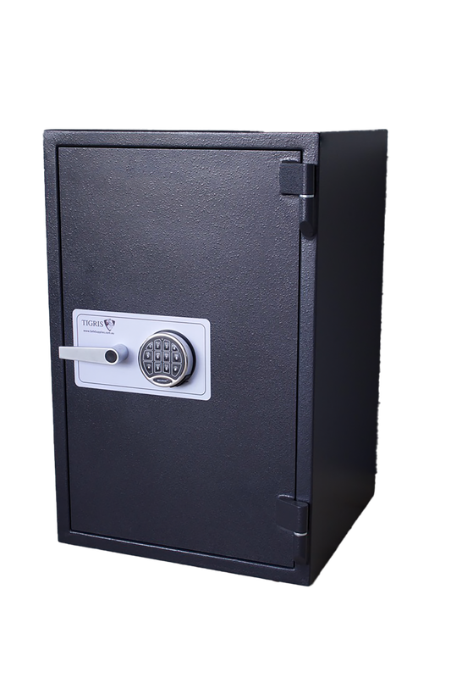
Description Complies to Australian Poisons and Therapeutic Goods Regulation Act 2008. All 10mm steel construction, with retractable locking bolt work, secured by a quality digital lock, can be fitted with card swipe access lock.4 x 12mm bolt holes in base and 4 x 12mm bolt holes in back. Has some paint chips and scratches

Price $2100 + GST
Internal Measurements
H
W
D
External Measurements
H 1800mm
W 570mm
D 500mm

Location Melbourne, Victoria
Fire Rating Nil
Cash Rating NA
Model Imperium Drug Safe 4
Picture 2 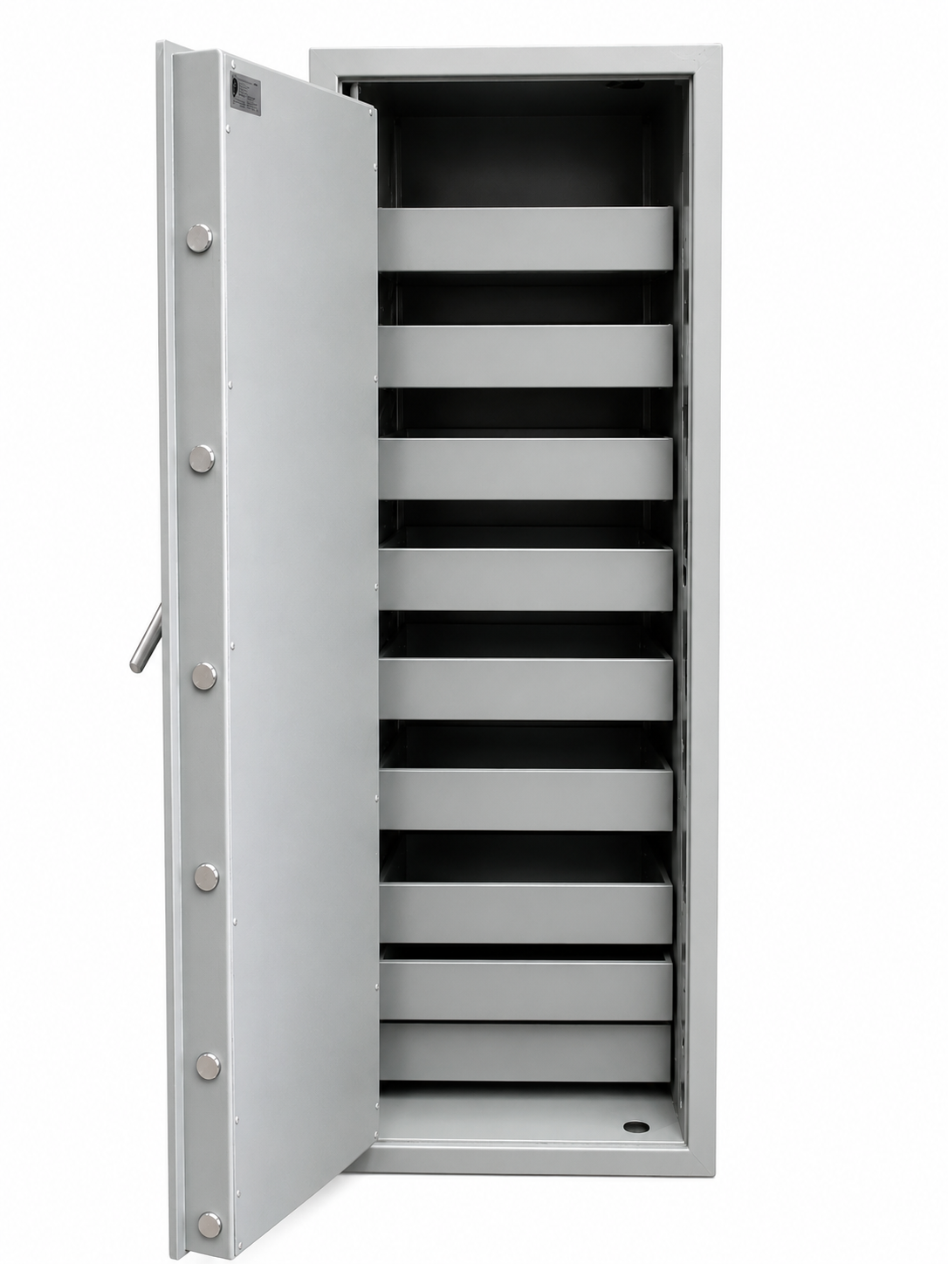
Picture 1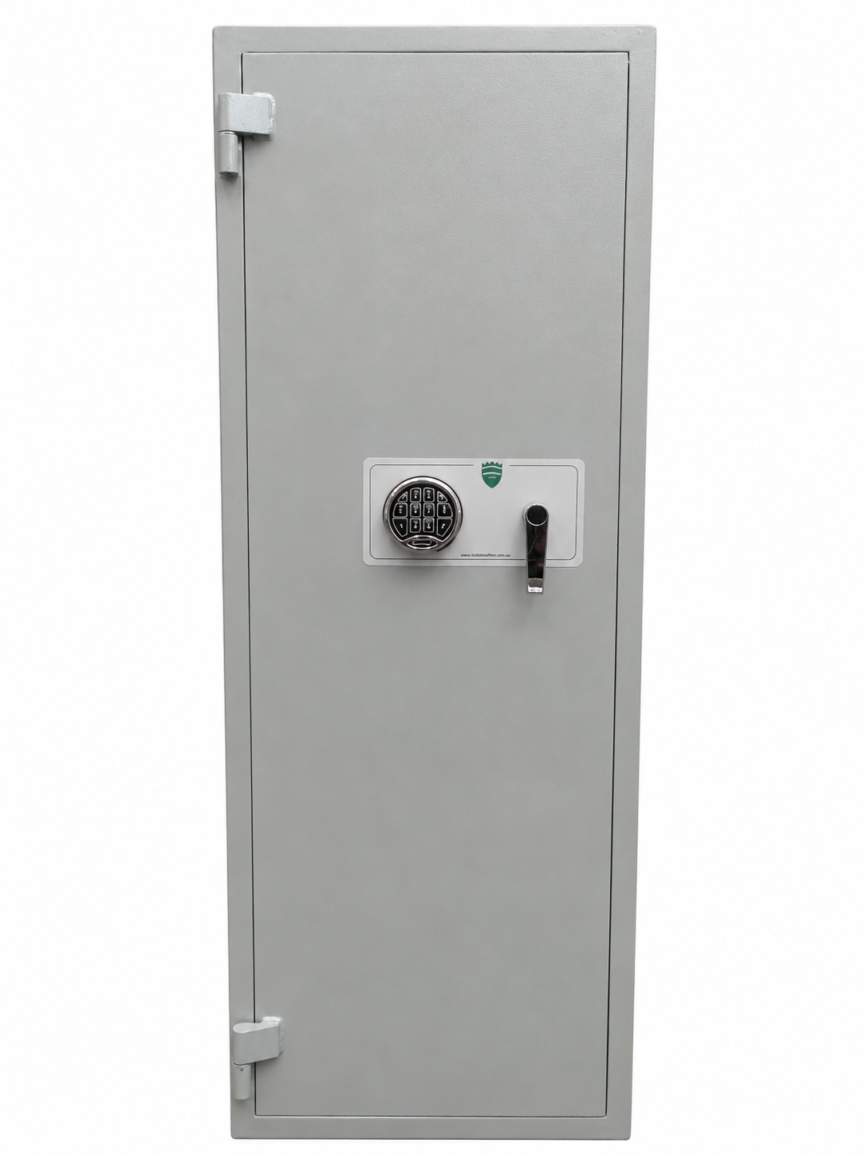
USED SAFE

