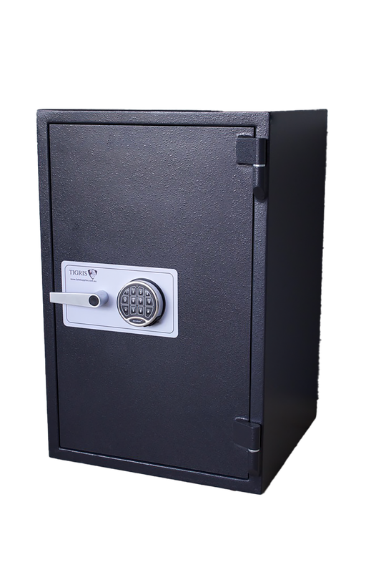
Description The Second Hand Chubb Europa Grade III Safe is a high-security commercial safe designed to provide exceptional protection for cash, jewellery, important documents and other valuable assets. Certified to EN 1143-1 Grade III, it offers trusted burglary resistance, making it ideal for businesses, pharmacies, jewellers and discerning homeowners.
Price $2500 + GST
Internal Measurements
H 550mm
W 500mm
D 400mm
External Measurements
H 720mm
W 720mm
D 660mm

Location Melbourne, Victoria
Fire Rating 60 Minutes
Cash Rating $100,000
Model Chubb Europa
Picture 2 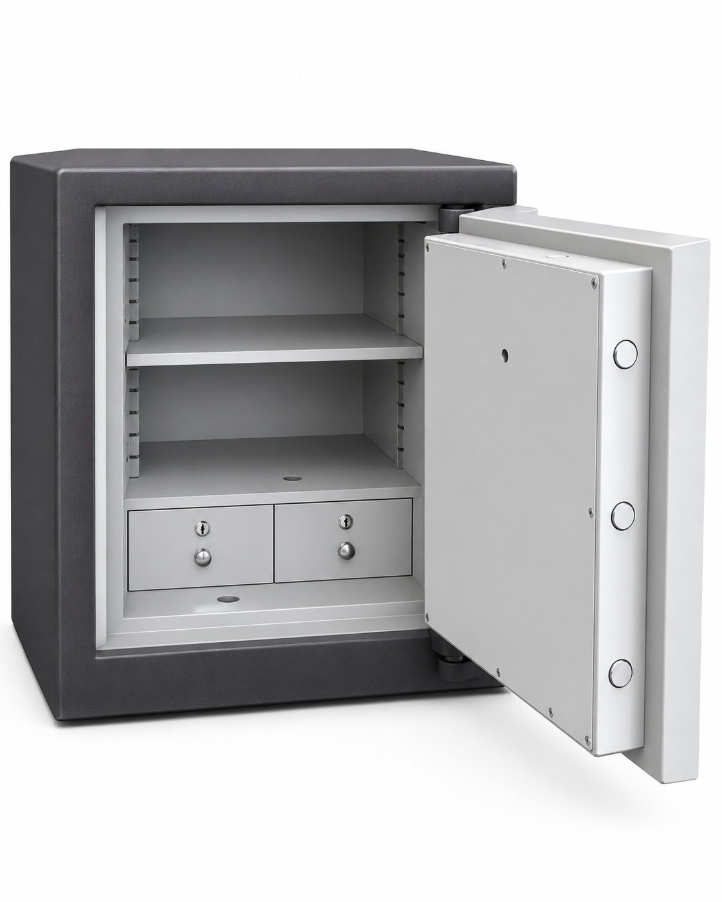
Picture 1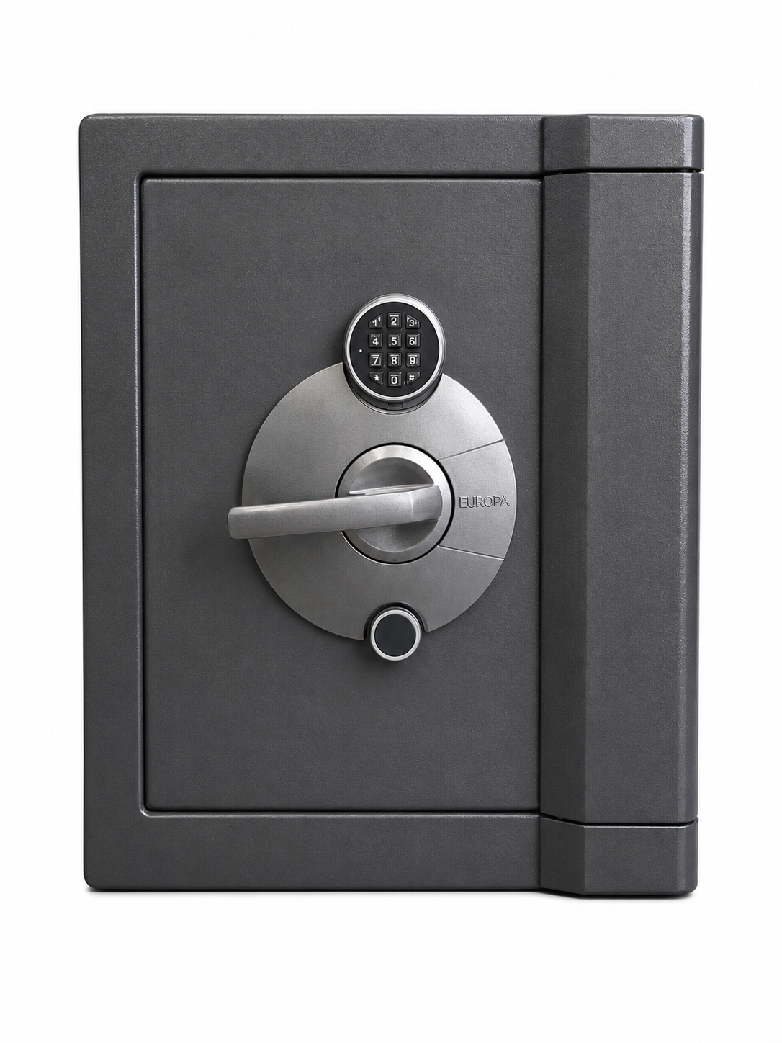
USED SAFE

